R:\MARKETING\Marketing\Pics\GE Logo\GE Logo.tifR:\MARKETING\Marketing\Pics\GE Logo\GE Logo.tif

**Kit contents:**   
  
Two metal linking bars.  
  
**Please read these instructions along with the instructions included with   
the half step.**

Ensure the step is stable before use.   
Periodically check and retighten all nuts or other fixings as required.

TRENT LANE  
CASTLE DONINGTON  
DERBY DE74 2PY  
ENGLAND

TEL: (01332) 810504  
INT: + 44 1332 810504  
FAX: (01332) 850830  
INT: + 44 1332 850830   
enquiries@gordonellis.co.uk   
www.gordonellis.com

Company registered in England: No. 231734  
vat no. GB 428 4666 26

Linking Kit

Suitable for:

LP/PHS  
66091

2

1

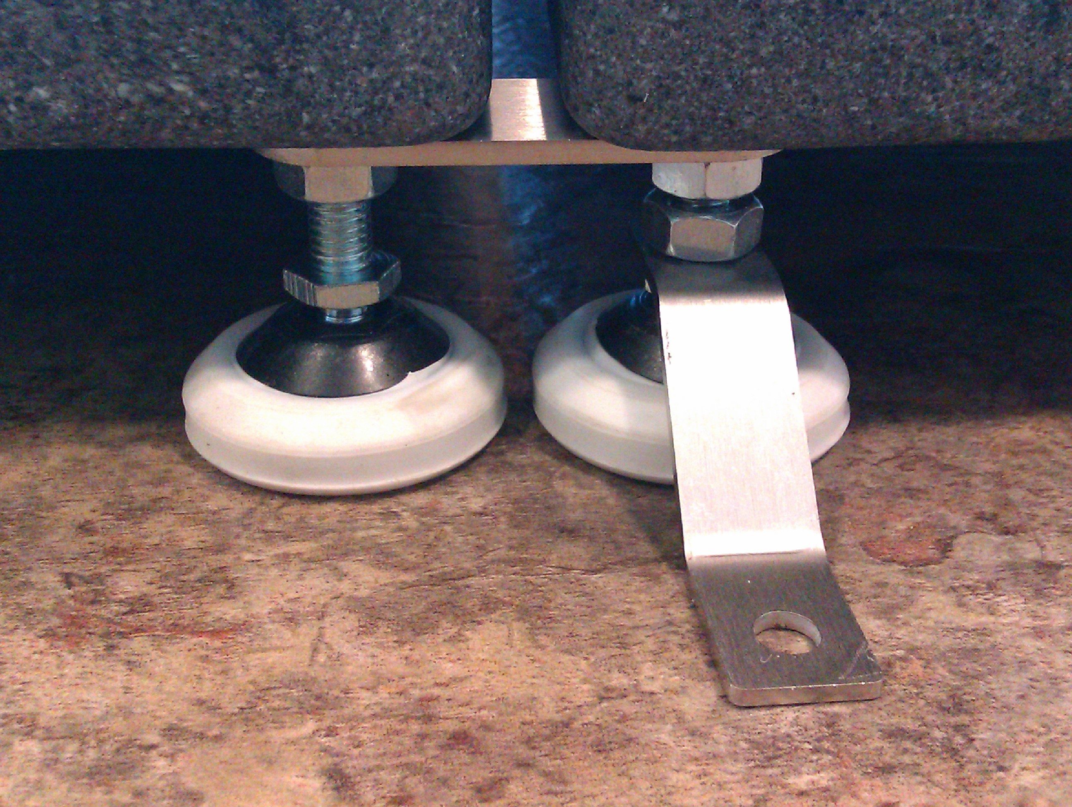

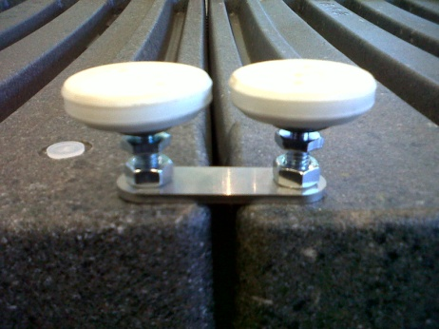

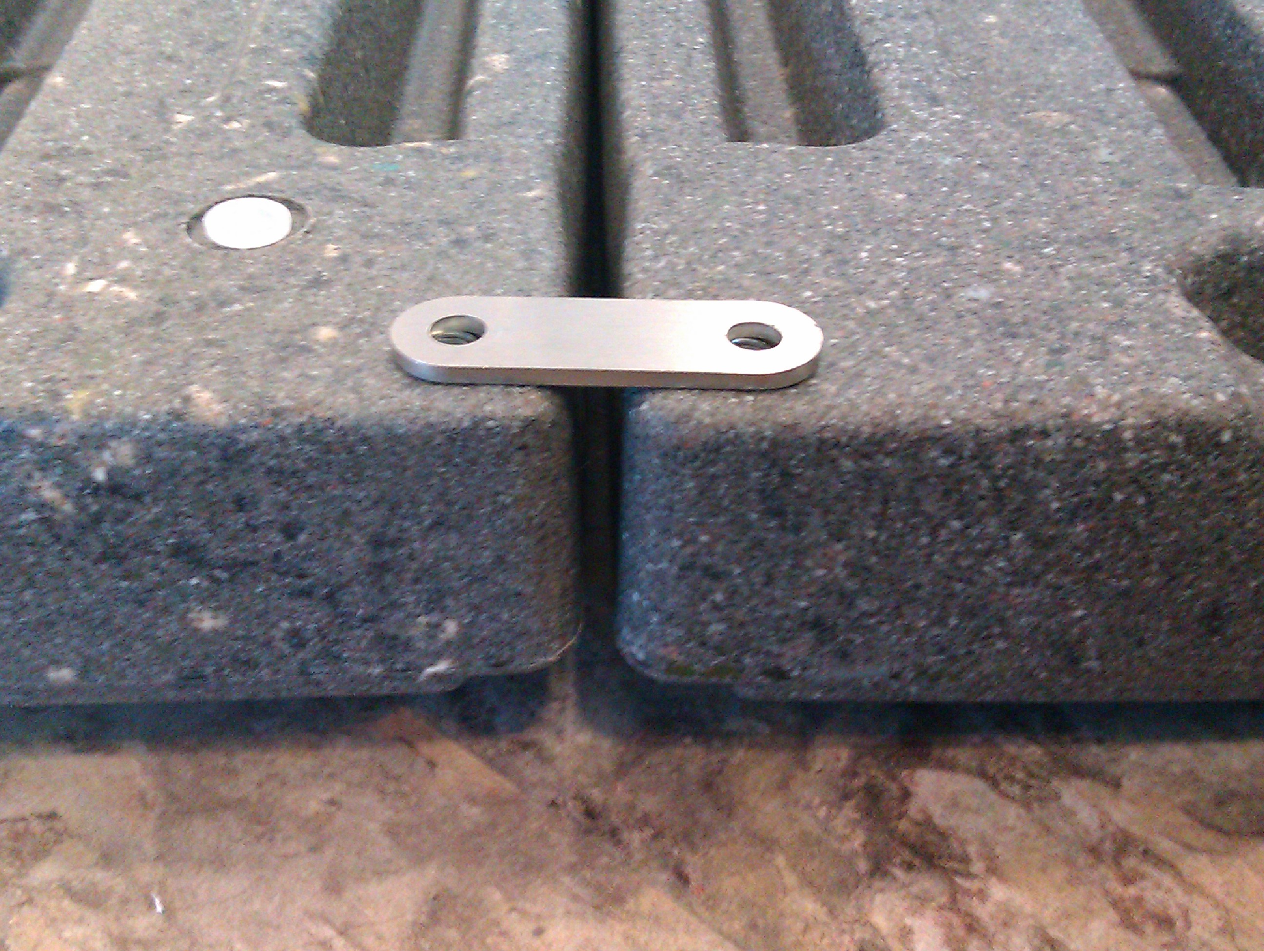

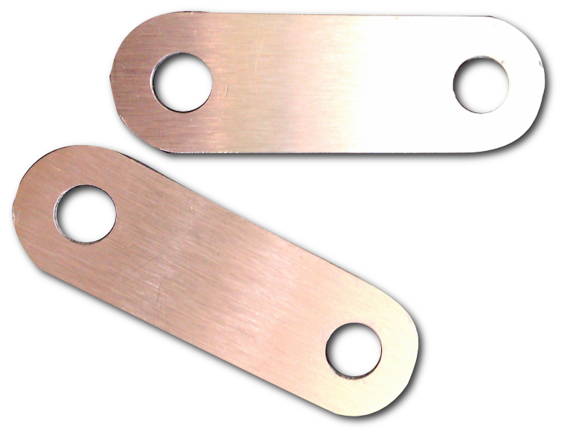

**61094-0211**

**If using the Linking Kit and Fixing Kit together:**

The linking kit goes above locking nut (B)

The fixing kit goes belowboth nuts (B+C)

**Safety considerations:**When fitted, the distance from the underside of the step to the end of the foot should be no more than 38mm. This is to ensure enough thread is inside the step for safe use.

Ensure both steps are securely joined and that they are stable before use.

**Fixing instructions:**  
Place the two LP/PHS or 66091 next to each other, upside down.  
  
Remove the four feet where the steps will be linked.  
  
(1) Locate a linking bar over the matching holes on each step. Repeat for the other two holes on the other side of the step.  
  
(2) Screw feet through the linking bar and tighten up securely, so that the locking nut is firmly against the linking bar.

**Fixing instructions:**  
Place the two LP/PHS or 66091 next to each other, upside down.  
  
Remove the four feet where the steps will be linked.  
  
(1) Locate a linking bar over the matching holes on each step. Repeat for the other two holes on the other side of the step.  
  
(2) Screw feet through the linking bar and tighten up securely, so that the locking nut is firmly against the linking bar.

2

1



**61094-0211**

**If using the Linking Kit and Fixing Kit together:**

The linking kit goes above locking nut (B)

The fixing kit goes belowboth nuts (B+C)

**Safety considerations:**When fitted, the distance from the underside of the step to the end of the foot should be no more than 38mm. This is to ensure enough thread is inside the step for safe use.

Ensure both steps are securely joined and that they are stable before use.

**Kit contents:**   
  
Two metal linking bars.  
  
**Please read these instructions along with the instructions included with   
the half step.**

Ensure the step is stable before use.   
Periodically check and retighten all nuts or other fixings as required.







Linking Kit

Suitable for:

LP/PHS  
66091

TRENT LANE  
CASTLE DONINGTON  
DERBY DE74 2PY  
ENGLAND

TEL: (01332) 810504  
INT: + 44 1332 810504  
FAX: (01332) 850830  
INT: + 44 1332 850830   
enquiries@gordonellis.co.uk   
www.gordonellis.com

Company registered in England: No. 231734  
vat no. GB 428 4666 26